Practical Assignment

1. Create a web page with the 3 <div> elements under that add <p>, <h4> tags and apply the inline CSS for the first <div> elements with the background-color property and for <p> element with color property. Also, apply the internal and external CSS to the remaining elements and check the cascading CSS order applied to all divisions. (Use Background color & color property)

Output:

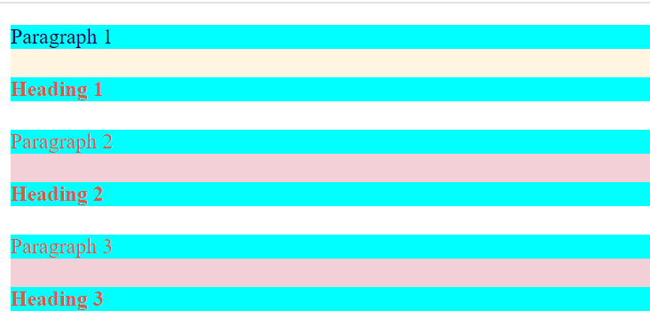

1. Create a web page with a <p>, <h1>, <div>, <ul>, <ol> elements with the proper content and apply the following selectors to apply the style.
2. ID Selector
3. Class Selector
4. Global Selector
5. Grouping Selector